Guided Capstone Project Report

Big Mountain Resort has recently installed an additional chair lift, which has increased the total operating costs by $1,540,000 in this season. The business is looking for a new ticket pricing strategy such that it can increase its revenue to cover the additional operating costs. It also wants some guidance on future investment in its facilities and properties. Previously, it was just charging a premium above the average price of resorts in its market segment. There are some limitations to this approach. For example, it is not maximizing its returns, relative to its position in the market. It also does not have a strong sense of what facilities matter most to visitors, particularly which ones they are most likely to pay more for. In order to provide some guidance for its pricing strategy and future facility investment plans, I performed an analysis using Random Forest modeling. My recommendations are summarized below.

The current ticket price of Big Mountain is $81.00, and the modeled price is $95.87. Even if the expected mean absolute error of the model is about $10.39, this suggests there is still room for an increase in the ticket price. To better understand Big Mountain Resort’s position in its market context, it would be useful to first take a look at the most important features from the modeling. As shown in the random forest modeling result, the top six dominant features in affecting the ticket price are: fastQuads, Runs, Snow Making_ac, vertical_drop, SkiableTerrain_ac and total_chairs, respectively.

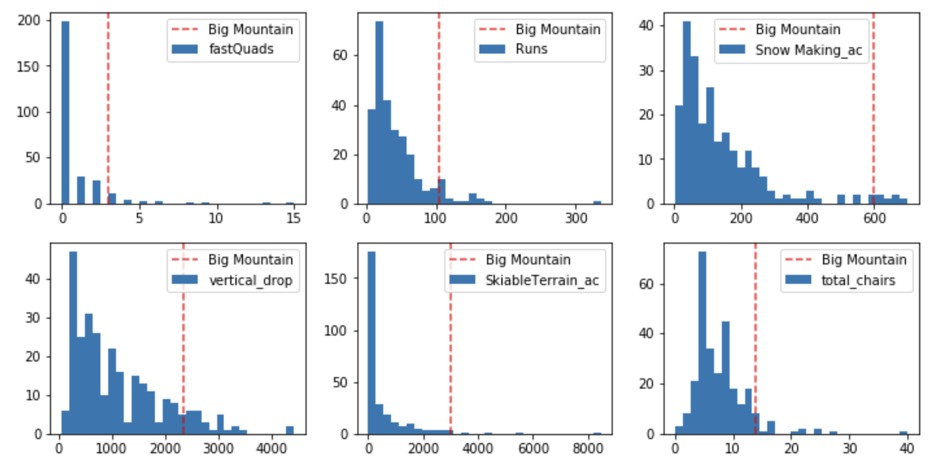

The histogram of the value of these features for all the resorts in Big Mountain’s market share is shown above. While most resorts have no fast quads, Big Mountain has 3 which puts it high up in this league table. It has a reasonable number of runs, and its snow making area is very high up in that league table. For vertical drop, it is doing well, but there are still quite a few resorts with a greater drop. It is also very high up in the league table of skiable terrain, and has amongst the highest number of total chairs. Based on the comparison of these features between Big Mountain and other resorts in its market share, I would highly recommend for an increase in Big Mountain’s ticket price.

Next, I would also like to recommend some future investment plans for Big Mountain’s facilities. The following estimate is based on the fact that the expected number of visitors over the season is 350,000, and on average, visitors ski for five days. In the first option, Big Mountain could increase the vertical drop by adding a run to a point 150 feet lower, and at the same time install an additional chair lift to bring skiers back up. With these changes, the model indicates that the ticket price can be increased by $1.99, and thus the expected revenue can be increased by $3,474,638. As we know, the operating cost of adding an additional chair lift is $1,540,000. Although the cost of adding another run is unknown, this increased revenue can potentially cover the increased operating cost of these changes. The model also indicates that increasing snow making coverage does not necessarily increase the ticket price, so it is probably not worthwhile investing in more snow making coverage. In the second option, Big Mountain can also close some of the least used runs to save its total operating costs. As shown in the figure below, the model says that closing one run makes no difference in ticket price. Closing 2 and 3 successively reduces support for ticket price and so the revenue. Closing down 4 and 5 has no further loss in ticket price compared to closing down 3 runs. Increasing closures down to 6 or more leads to a large drop. It would be very helpful to know the operating cost of one run in this scenario. Then I would recommend closing either 2 runs or 5 runs depending on the operating cost of one run.

